**\*AmberCry Kit Power on and Startup Guide\***

**Network Information:**

The kit network is 10.1.x.x/16. Each individual kit has it's own subnet, kit 1 is 10.1.6.x, kit 2 is 10.1.7.x, and kit 3 is 10.1.8.x

|  |  |  |  |
| --- | --- | --- | --- |
| **SERVICE** | **IP** | **USER** | **PASSWORD** |
| CMC | http://10.1.x.2 | root | Br111ckSquad!!! |
| iDRAC Blade 1 | http://10.1.x.3 | root | Br111ckSquad!!! |
| iDRAC Blade 2 | http://10.1.x.4 | root | Br111ckSquad!!! |
| ESXi | http://10.1.x.10 | root | Br111ckSquad!!! |
| Splunk | http://10.1.x.50:8000 | admin | Br111ckSquad!!! |

**Definitions:**

* **iDRAC:** Integrated Dell Remote Access Controller. Allows users to manage a server remotely.
* **CMC:** Chassis Management Controller. Allows users to manage the chassis remotely.

**Required Components:**

- Kit x Chassis (Chassis front pictured below)

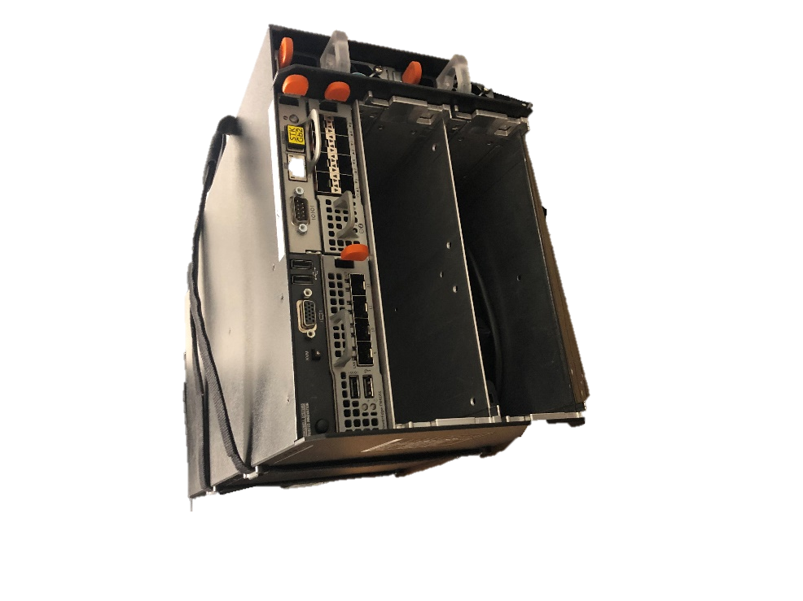

- Kit x Blades 1 and 2 (blade front and top pictured below)

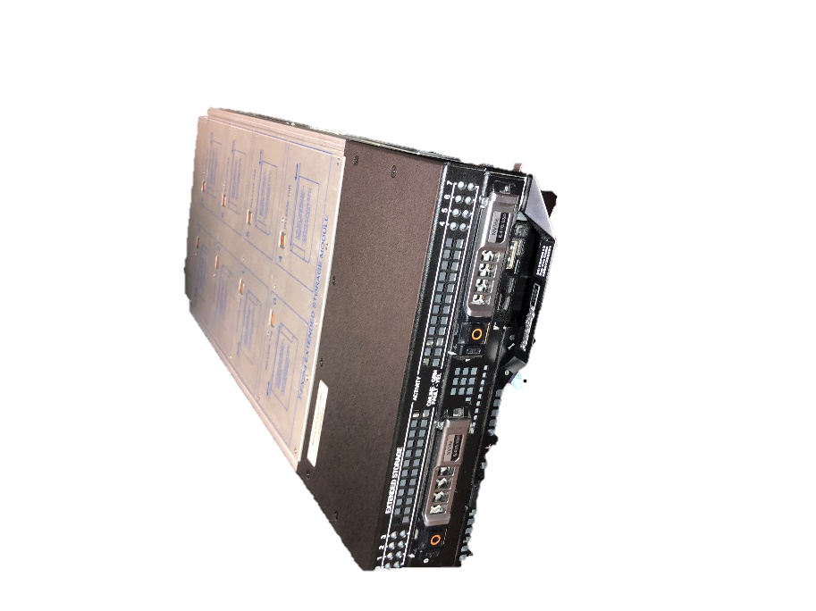

- Three RJ45 tipped ethernet cable

- One SFP 1G Ethernet adapter(Top of SFP pictured below)

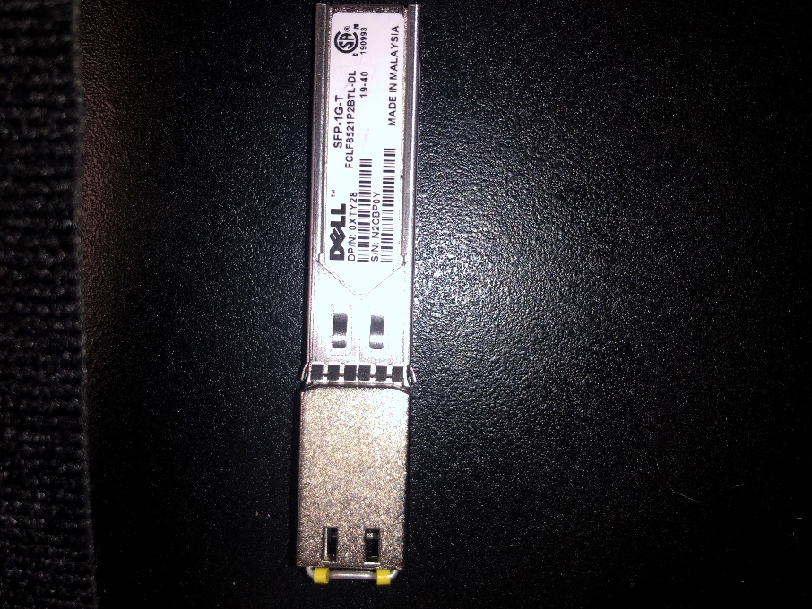

- One TPLink Unmanaged Switch

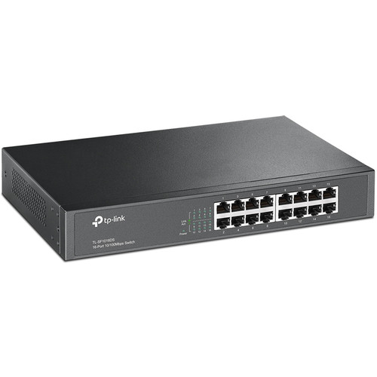

- One Laptop

- All associated power cables and surge protectors

**Background Information**:

a) It is important to ensure that the kit blades go to the matching kit chassis, e.g. Kit 1 Blades to Kit 1 Chassis. You can tell using the serial numbers on the kit blades and chassis and referring them against the table below. They will not network correctly if plugged in wrong.

|  |  |  |  |
| --- | --- | --- | --- |
| **KIT NUMBER** | **CHASSIS SERIAL** | **BLADE1 SERIAL** | **BLADE2 SERIAL** |
| 1 | ID9K1-03-01 | ID9K2-06-01 | ID9K2-06-02 |
| 2 | ID9K1-03-02 | ID9K2-06-03 | ID9K2-06-04 |
| 3 | ID9K1-03-03 | ID9K2-06-05 | ID9K2-06-06 |

b) On the Chassis, the serial number is located on the Lefthand side from the front. On the blades, the serial numbers are located on the top of the blade towards the front.

(Serial number location and correct serial number examples are pictured below)

CHASSIS:

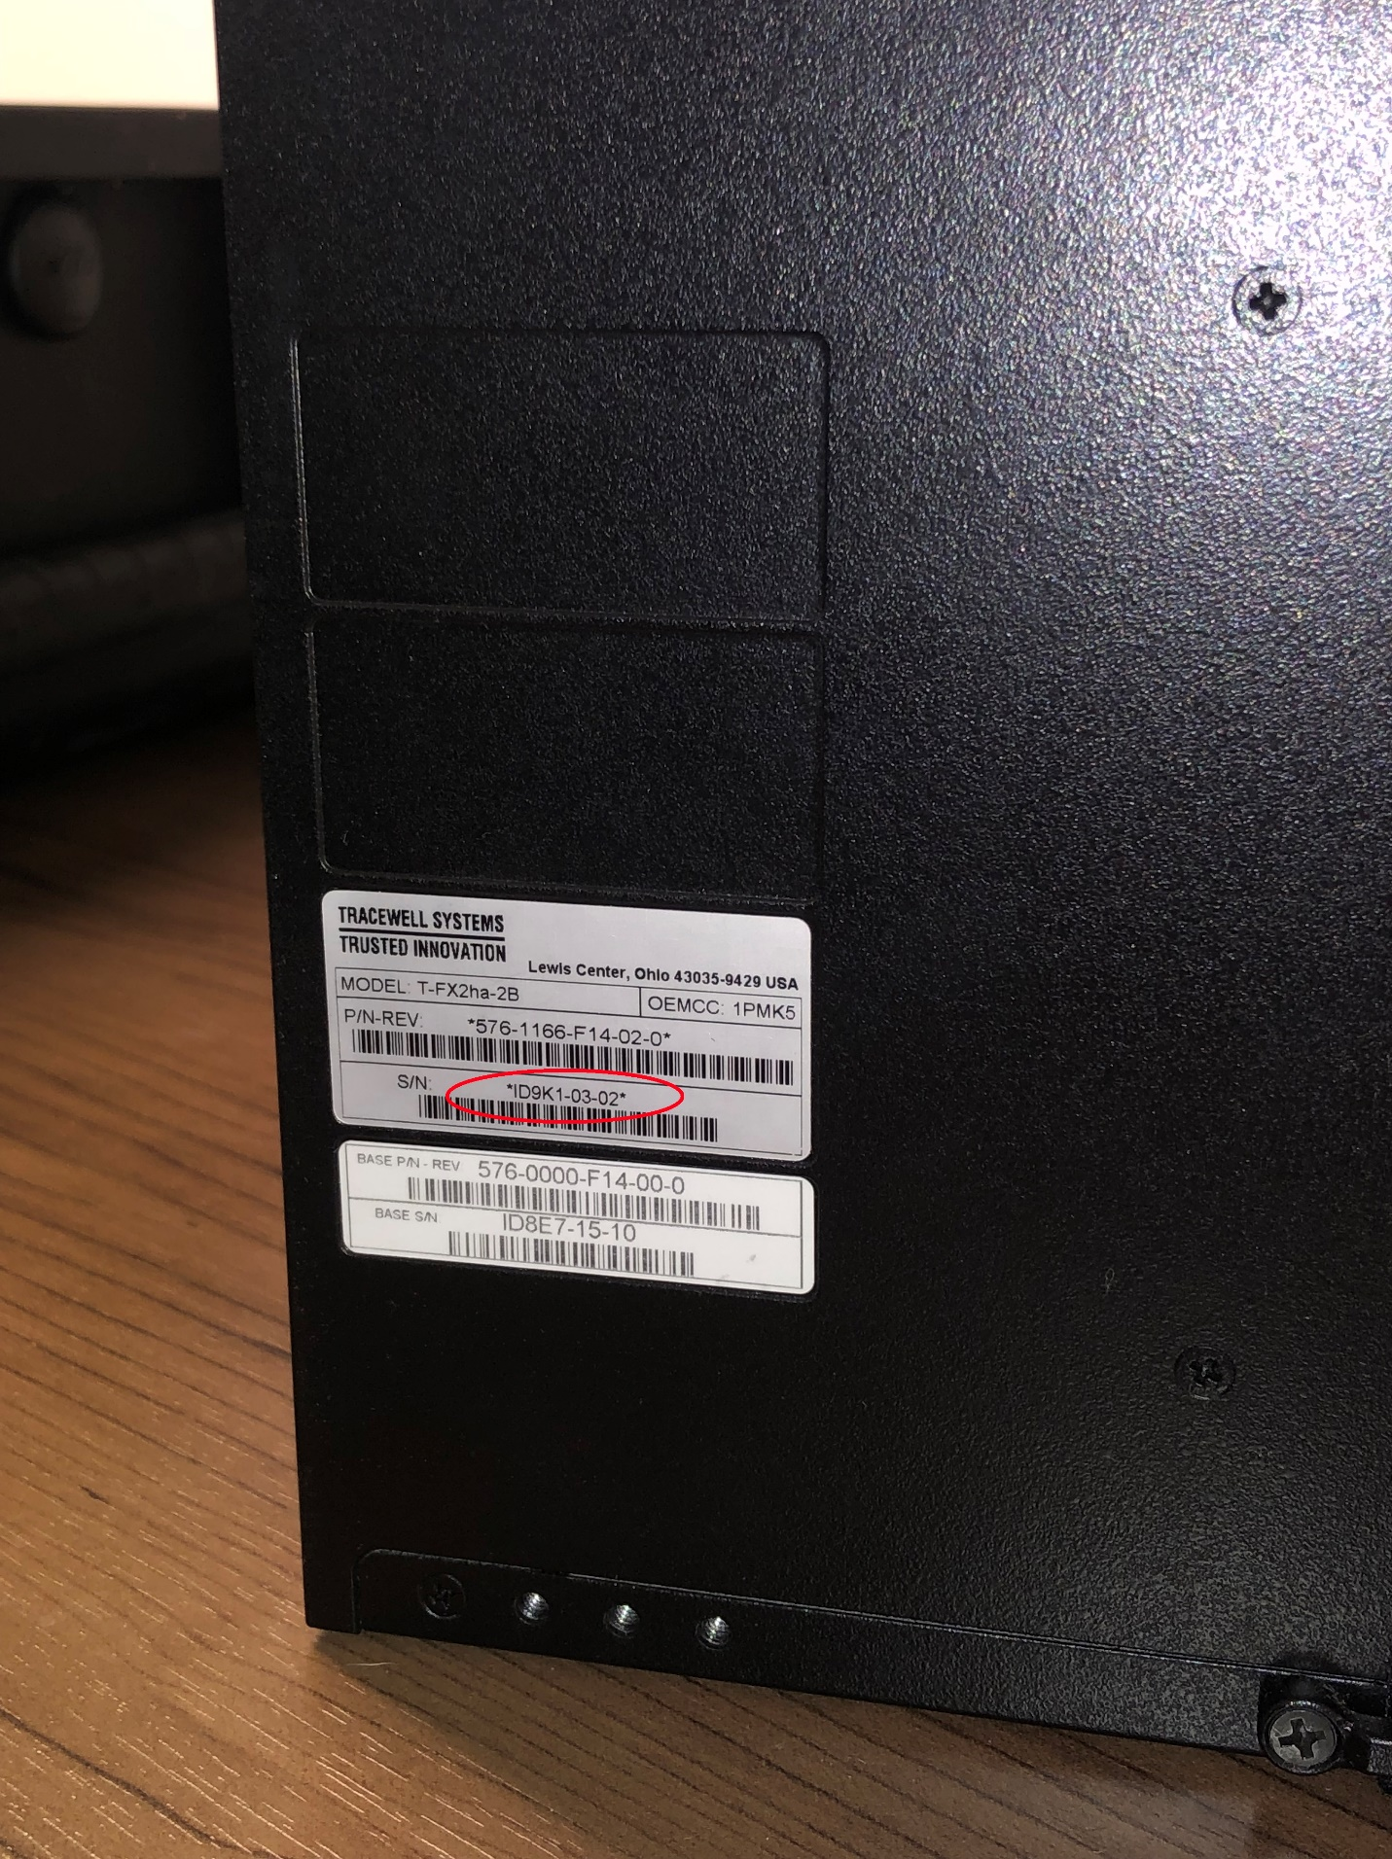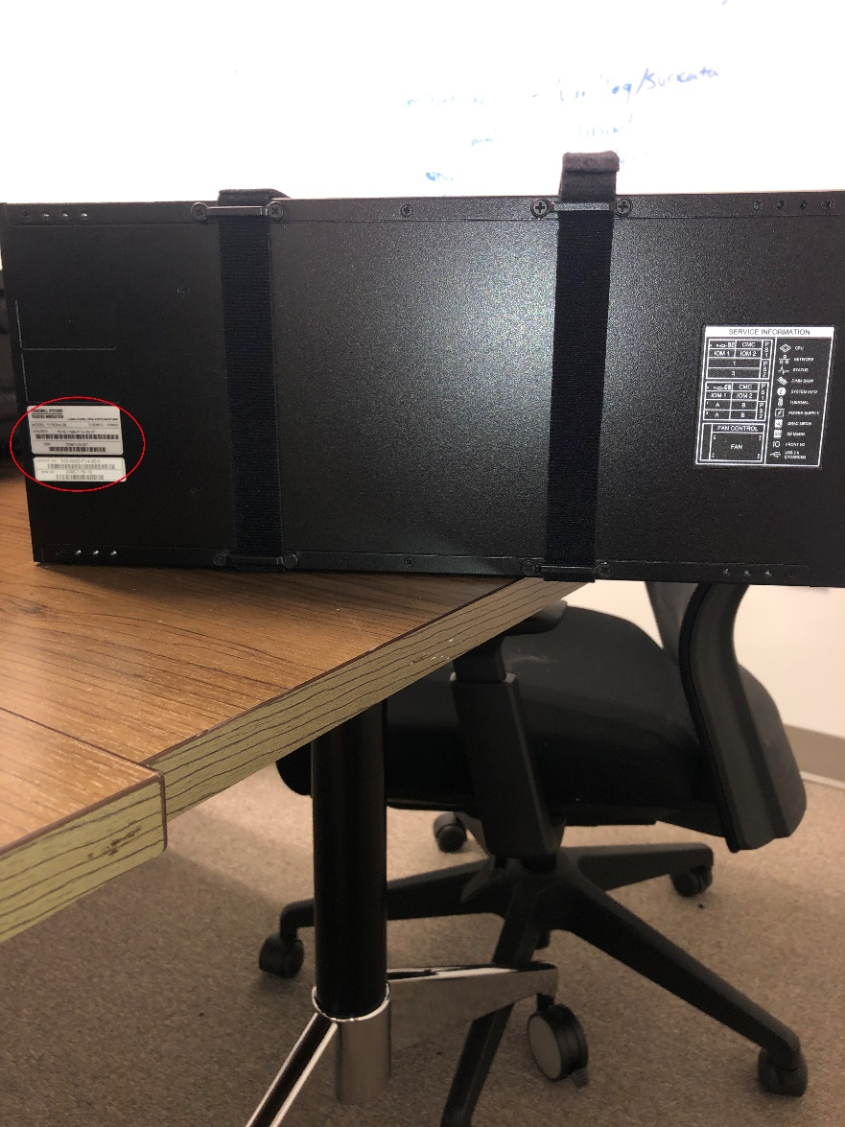

FRONT

BLADES:

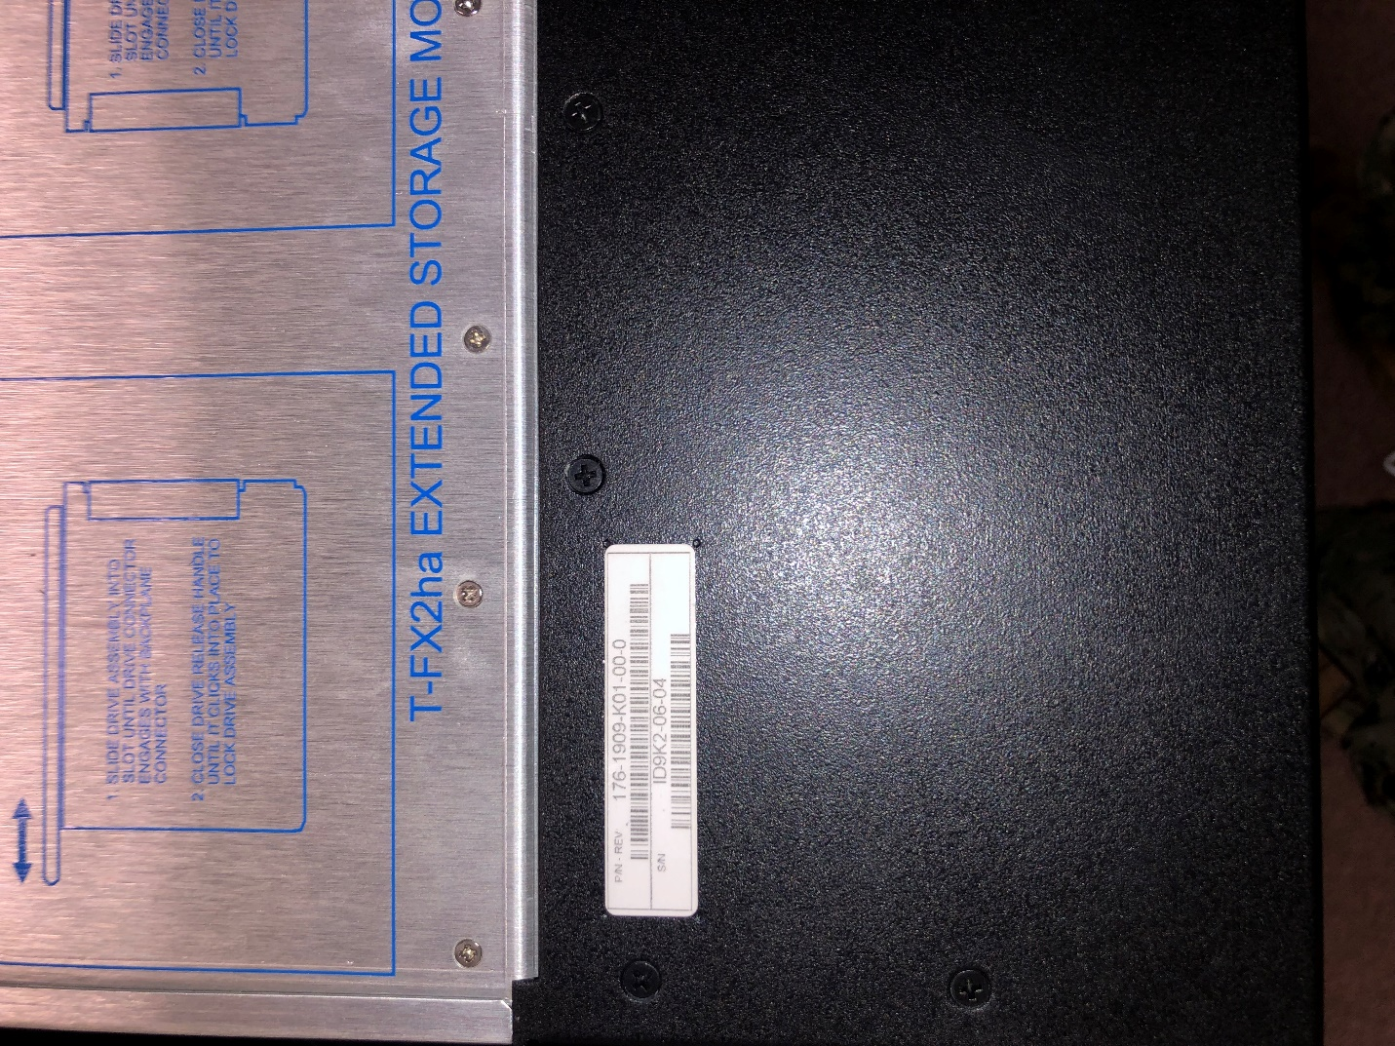

FRONT

c) On the chassis, in the top row of input ports, more on the right side of center, there is an ethernet port labelled '**GB1**' that allows a user to plug in a laptop to access the CMC. You will need to plug in one ethernet cable here, subsequently referred to as the "Chassis Management Port"



d) Below the Chassis Management Port, there are a total of twelve larger ports. These ports cannot be plugged into with just an RJ45 Tipped ethernet cable. They require an SFP to be plugged in first. Install the SFP with the serial number facing upwards, and then plug the ethernet cable into the SFP.

e) To explain the ports on the chassis, ports labelled 1-4 are wired directly into the top blade. Ports labelled 5-8 are wired directly into the bottom blade. Ports labelled 9-12 are more complicated. They network the blades together and will provide data from both blades just by plugging into one of them.

f) Further explanation of the ports on the chassis, ports labelled 3, 4, 7, 8, 10, and 12 are disabled. If you plug anything into them, you will not receive data or connectivity. Furthermore, Ports labelled 9 and 11 are both able to transmit data from all of the following ports: 1,2,5 and 6. So to network the kits as simply as possible, install an SFP in port 9 to maintain connectivity to all blades and their active ports.

**POWER ON AND STARTUP STEPS:**

**WHILE INSTALLING SERVERS OR PLUGGING IN CABLES, IF THE ITEM BEING INSTALLED/PLUGGED IN HAS TO BE FORCED, YOU ARE DOING IT WRONG. THINGS WILL FIT NICELY INTO PLACE, AND IF YOU ARE HAVING ISSUES, CONTACT INFRASTRUCTURE PERSONNEL.**

1. Begin by designating where you have enough space and convenience to set up the AmberCry Kit. There needs to be a nearby power source to plug in a surge protector.

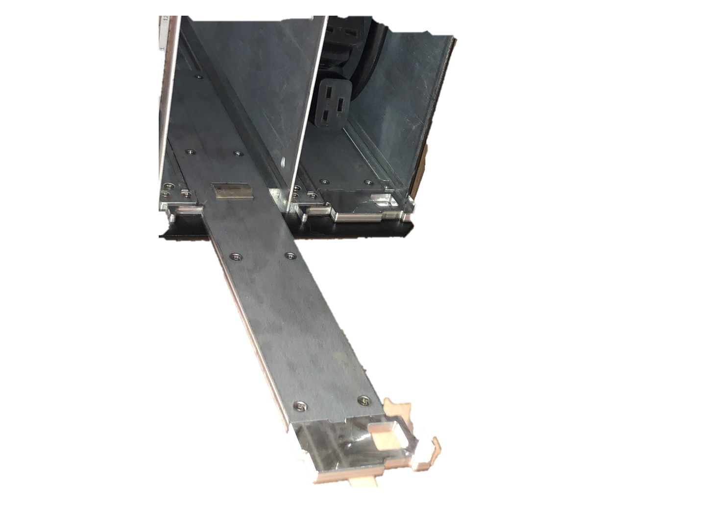 2. Pull out the Chassis from the pelican case. Verify the serial number and place the chassis where you want to set it up. On the chassis, there are arms on the left and right sides inside the blade slots that need to be slid out before installing the blades. They slide out much like dresser drawer rails. There is an upside-down 'L' shaped tab above each arm that needs to be pushed up to slide those arms out. See Below:

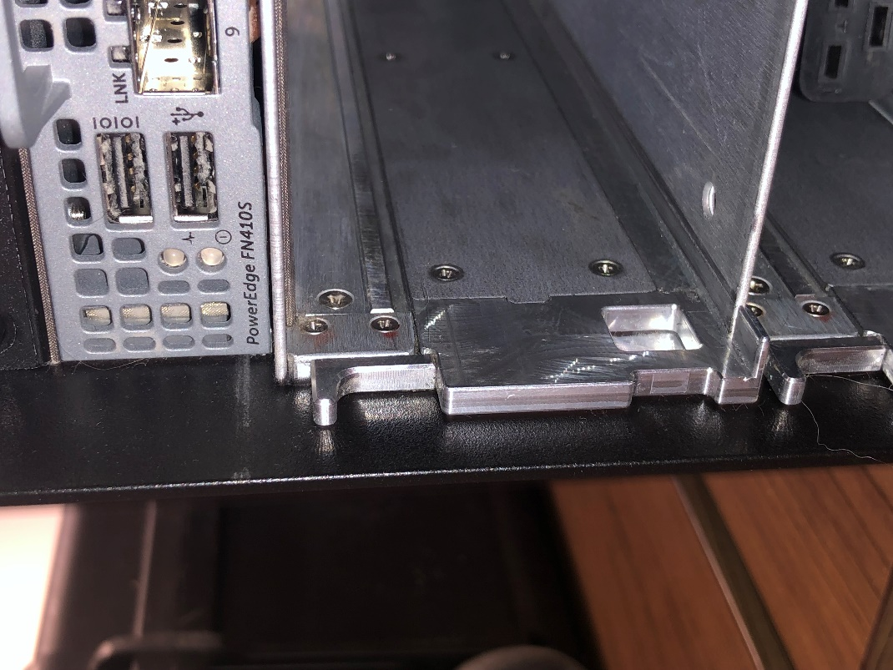

3. Pull out the first blade from the pelican case. Verify the serial number to ensure it is being installed in the correct chassis. Blade 1 goes in the top bay and Blade 2 goes in the bottom bay. On the front of the blade, there is a small locking handle with a blue tab on it. Release the handle by pulling the blue tab and swing that handle out before installing the blades. Slide the blade into the slot gently until it will not go further, then close the locking handle to lock it in place. You should hear an audible 'click'. SEE BELOW:

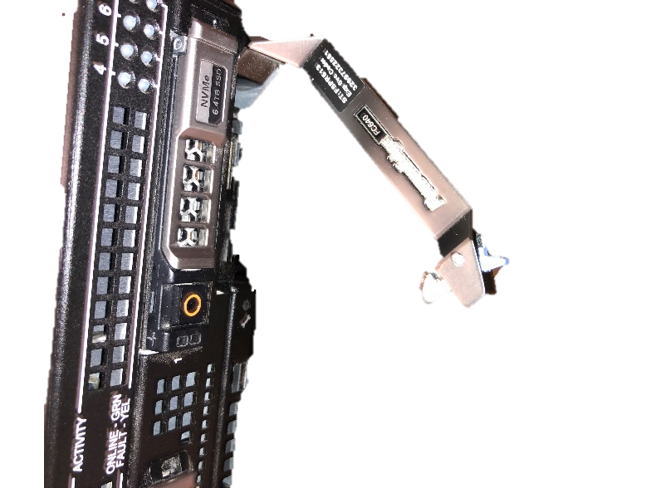

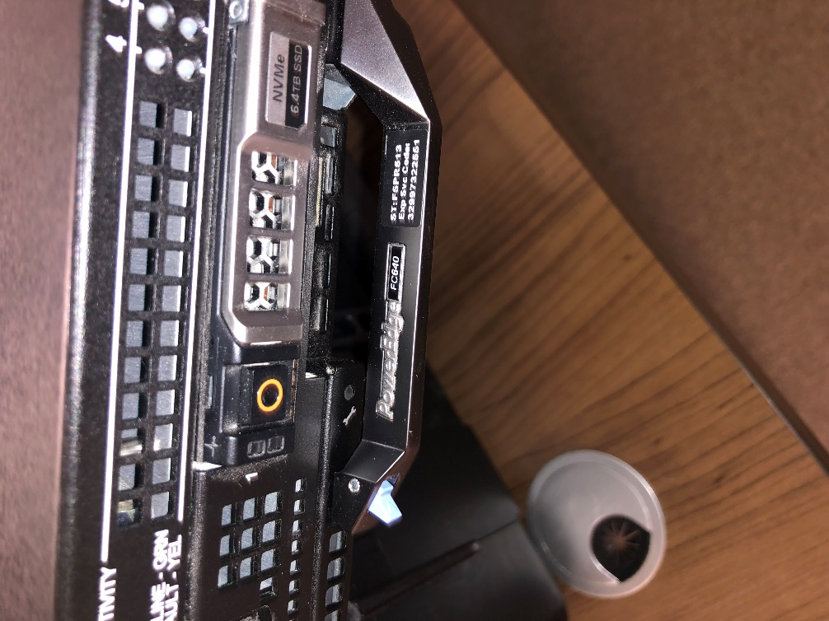

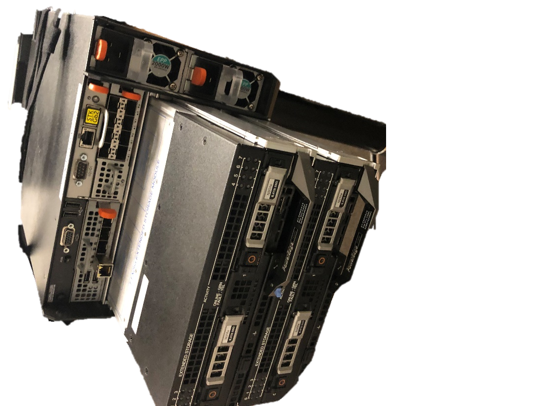

4. After installing the blades, place the unmanaged switch on top of the chassis. Plug one ethernet cable into the analyst laptop and plug the other end of the ethernet cable into any port of the switch. It does not matter which port because it is an unmanaged switch.

5. Plug one ethernet cable into the Chassis Management Port and plug the other end of the ethernet cable into any port of the switch. It does not matter which port because it is an unmanaged switch. SEE BELOW:

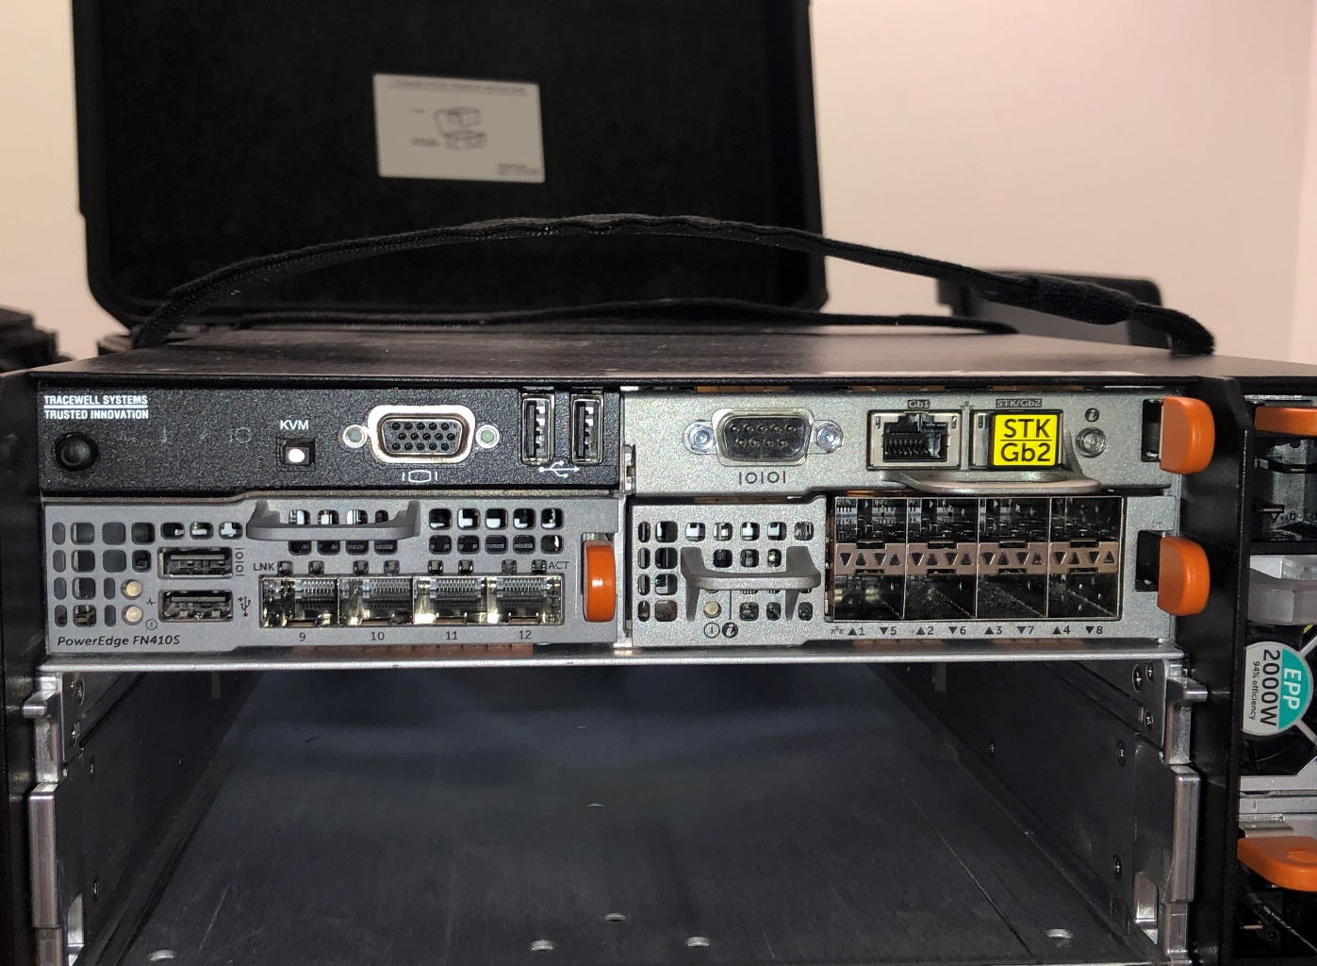

6. Install an SFP into port 9 on the Chassis with the label up, then plug an ethernet cable into the SFP. Then plug the other end of the ethernet cable into any port of the switch. It does not matter which port because it is an unmanaged switch. SEE BELOW:



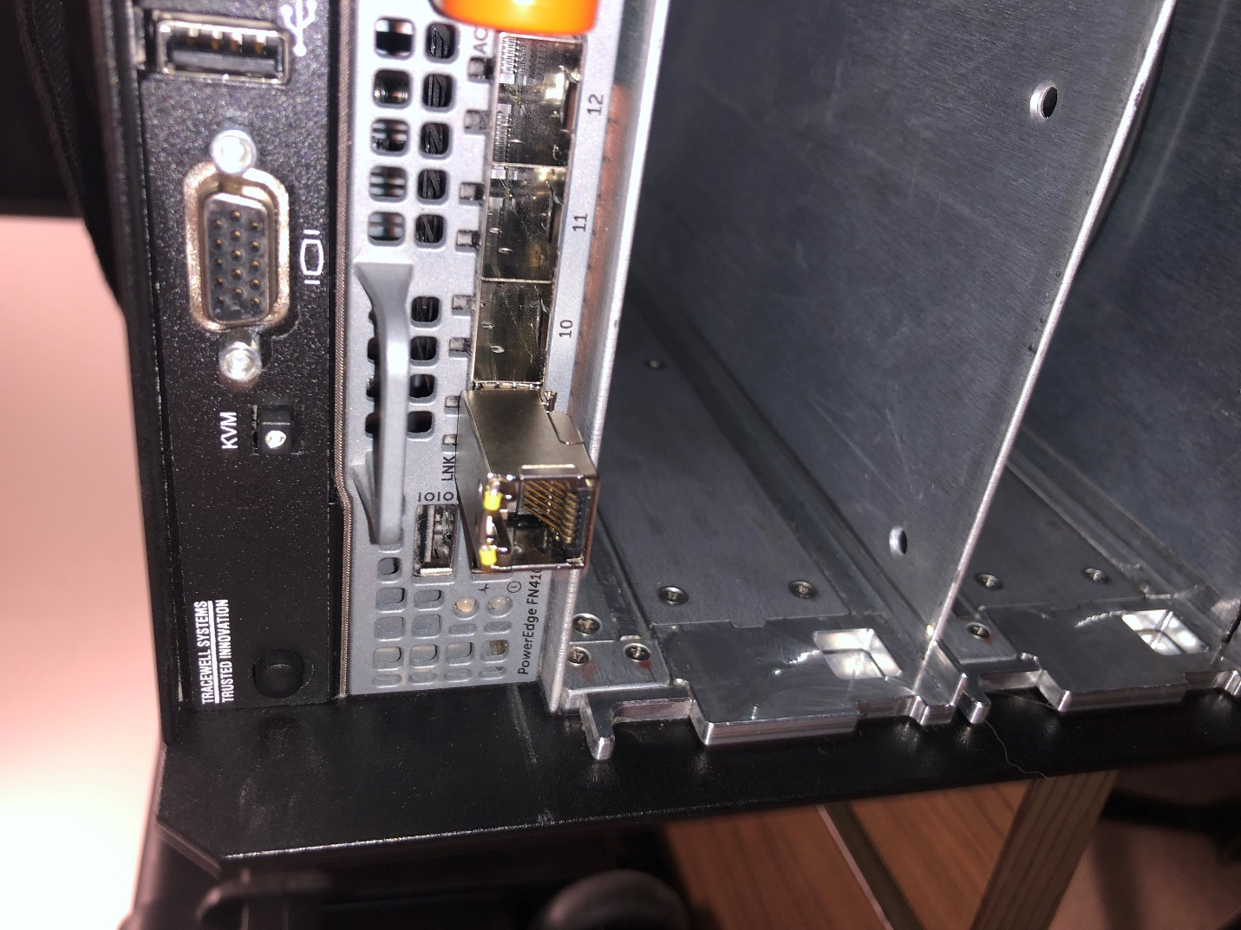

**\*\* BEFORE POWERING ON THE KIT, ENSURE ALL ETHERNET CABLES ARE PLUGGED IN WHERE THEY NEED TO BE. IF NOTHING IS PLUGGED IN WHEN THE KIT IS POWERED ON, ALL PORTS WILL BE DISABLED\*\***

7. Plug the power cables into the surge protector, the chassis, and the switch. Verify the Surge Protector is turned on. The chassis will have the power ports on the right-hand side on the front of the chassis. Once power is connected, the fan blades will spin quickly for a short period of time. This is normal. SEE BELOW:

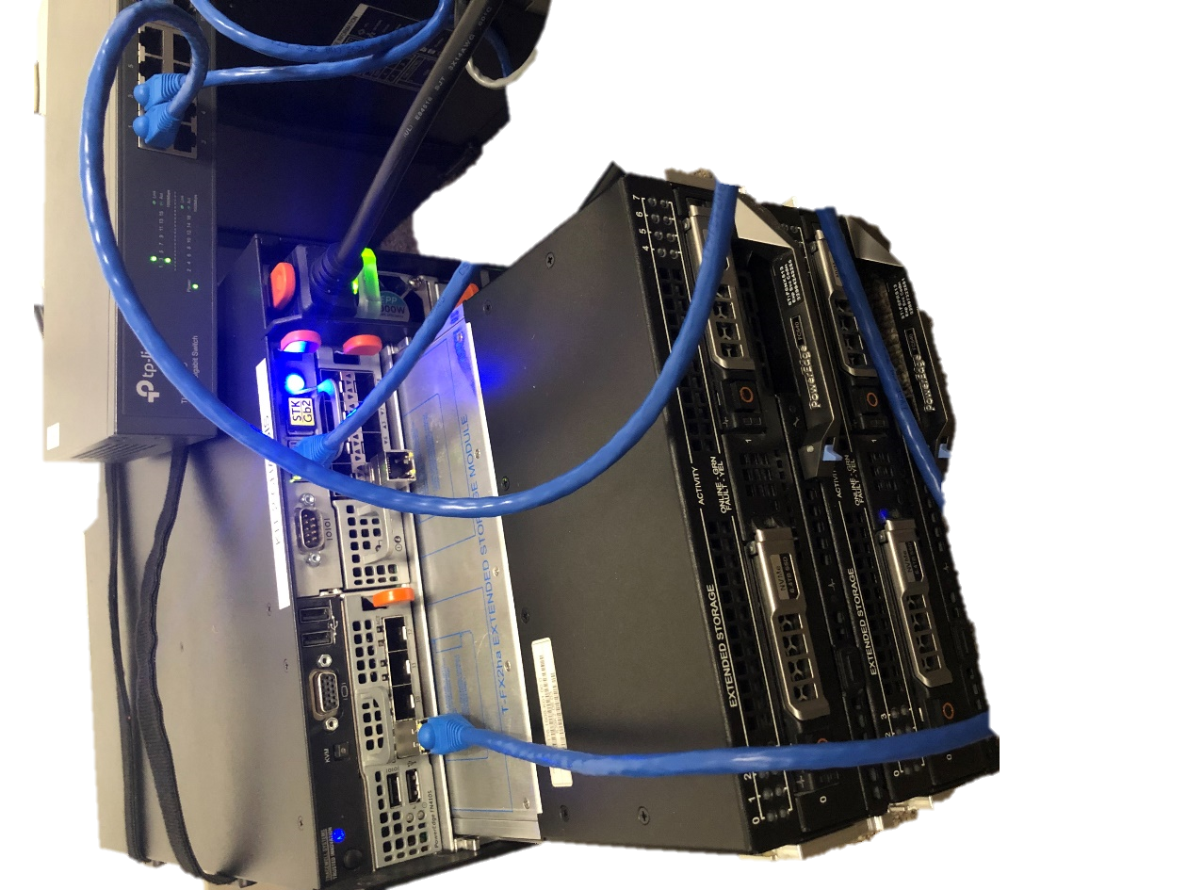

8. It may take a few minutes before the blue 'heartbeat' light located on the left-hand side of the front of the chassis and next to the power button is lit, but once the blue 'heartbeat' light turns on, press the chassis power button. It will light up green if it is beginning to power on. The fans will spin again and stay on this time. This is normal. SEE BELOW:

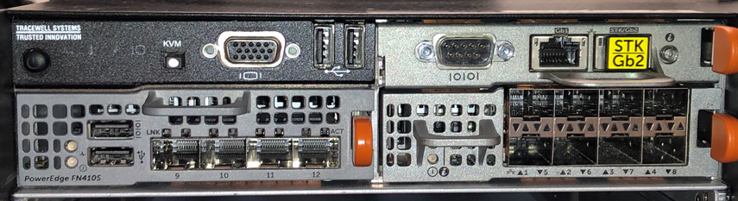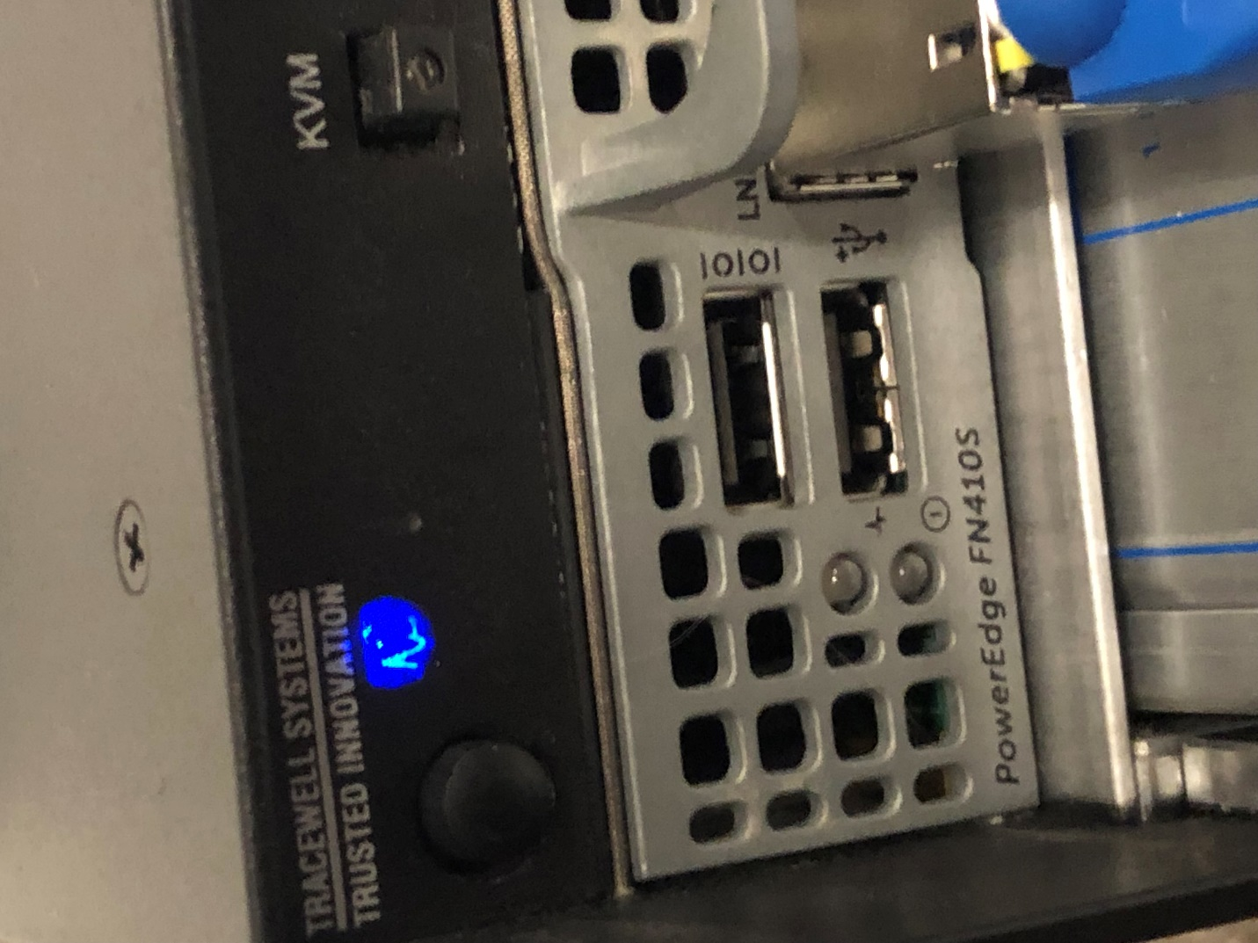 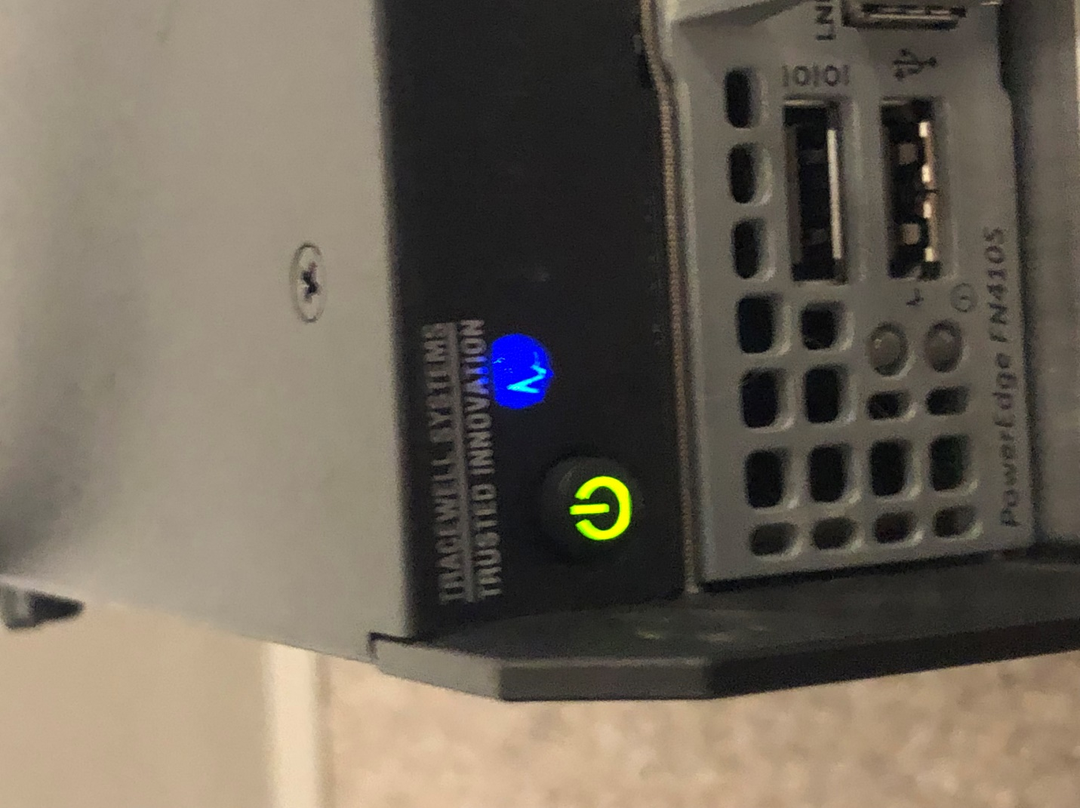

9. Wait a few moments, then log into the laptop with the password **'Br111ckSquad!!!**'. Open a Google Chrome Browser and navigate to <http://10.1.x.2>

**FOR ALL IP ADDRESSES CONTAINING AN ‘X’, THE X IS A VARIABLE FOR THE KIT SUBNET IP, SPECIFIED ABOVE**

10. Log into the CMC using the user of 'root' and password '**Br111ckSquad!!!**'. When logged in, on the left side of the browser window you will see a section titled 'Server Overview'. You will see that there are four items beneath that, but only two are available, these would be 1 and 3. This is normal. The 1st selection goes to Blade 1 and the 3rd selection(or only other available option) goes to Blade 2. SEE BELOW:

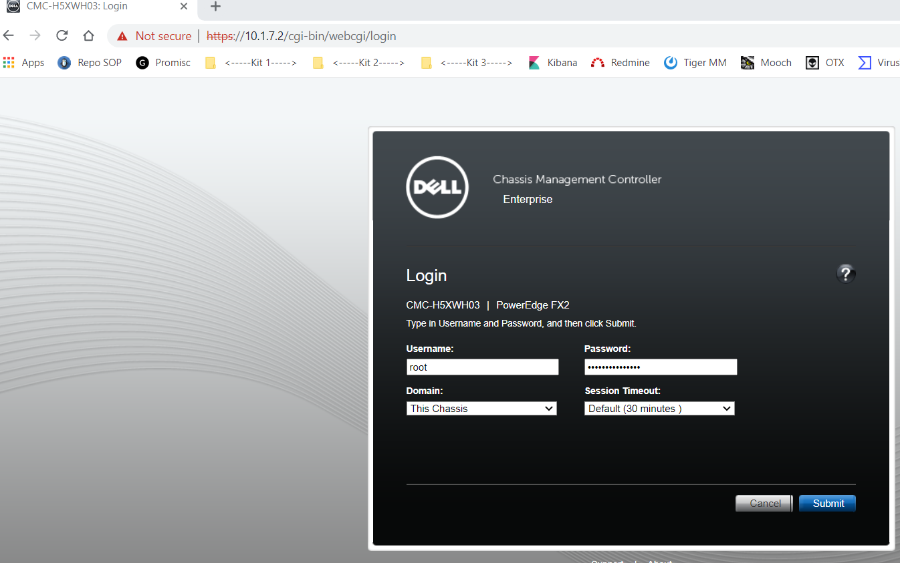 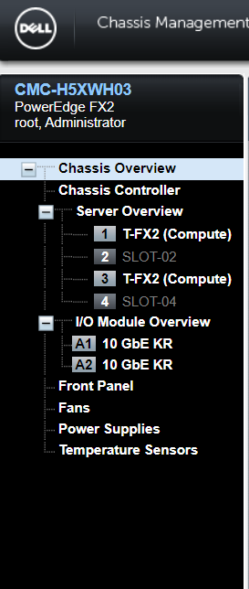

11. Select the 1st server from the list to manage Blade 1. Select 'Power', then select 'Control'. When the power control options load, ensure 'Power On' radio button is selected, then click the blue "Apply" button near the bottom. You will be asked if you want to execute the server control action. Select yes. Repeat for Blade 2. To verify they are powered on, look for lights on the front end of the blade. If none are lit, the blade is not powered on. SEE BELOW:

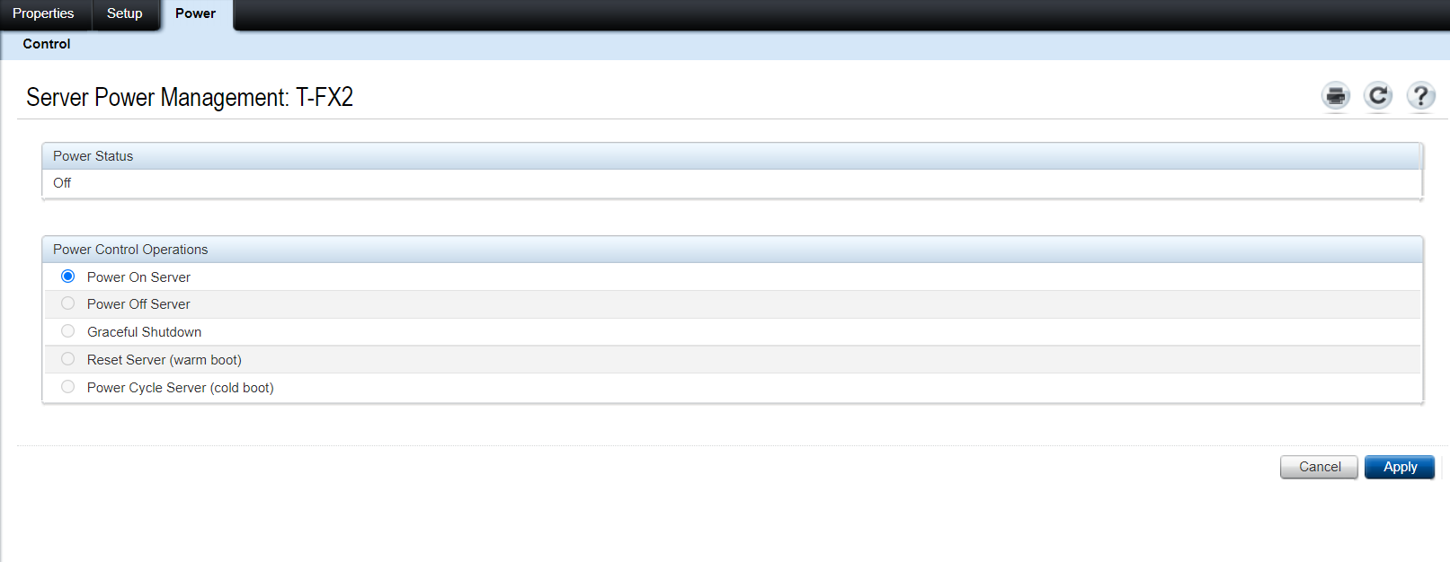

12. Navigate to the Blade 1 iDRAC IP at http://10.1.x.3. Log in with the user of 'root' and the password '**Br111ckSquad!!!**'. SEE BELOW:

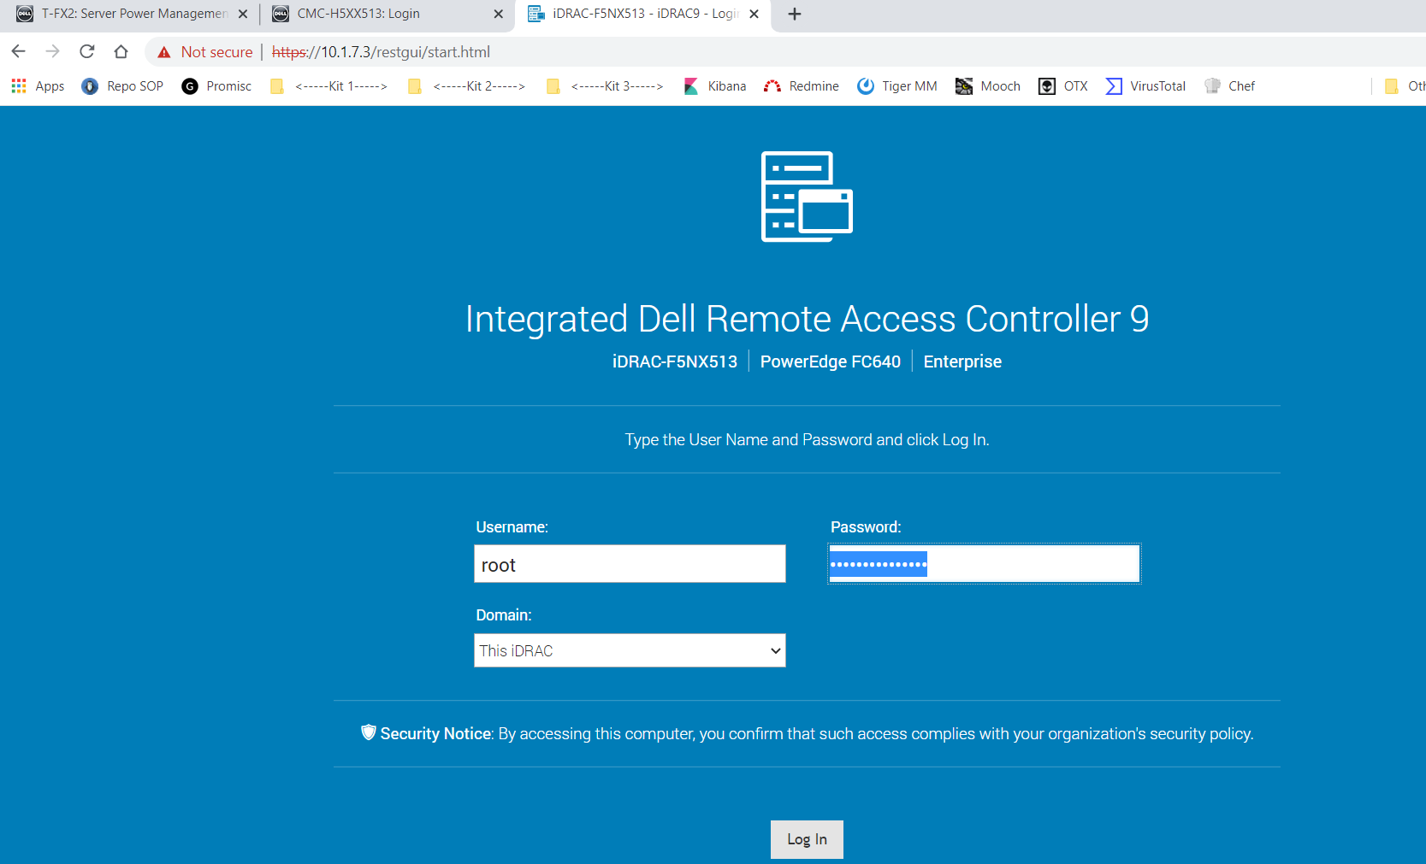

13. Scroll to the bottom of the page once logged in. On the right side of the web page will be a thumbnail underneath a title that says "Virtual Console". Click on the thumbnail.

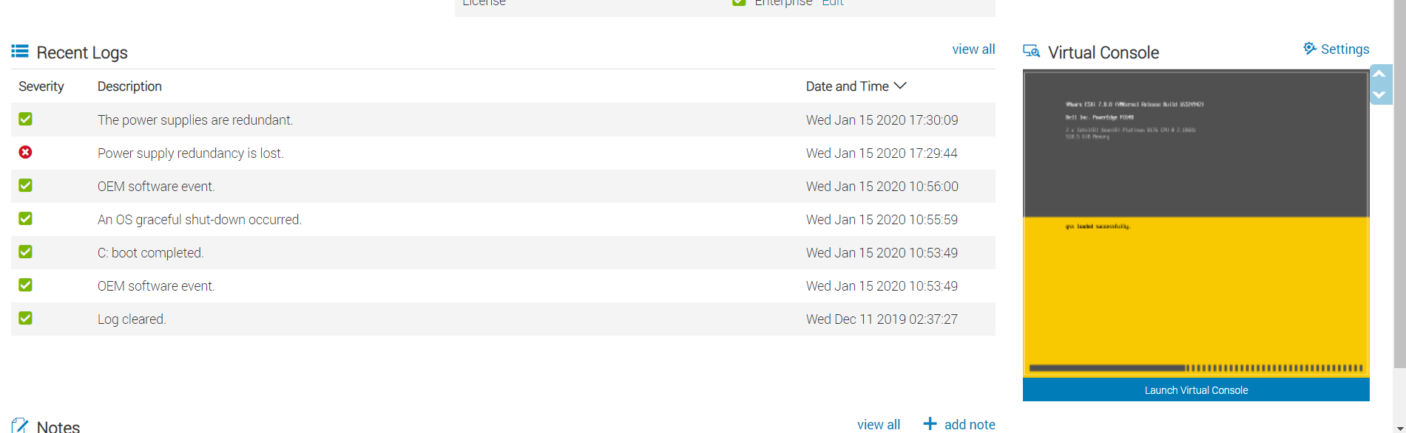

14. A new window will open that will show a boot process. This is going to be the Boot up process for ESXi and it may take a few minutes to complete. Do not press any options, let it boot to the preset defaults. You will know that the boot process is complete when you see a menu that says something to the effect of "Navigate to http://10.1.x.10 to manage this device"

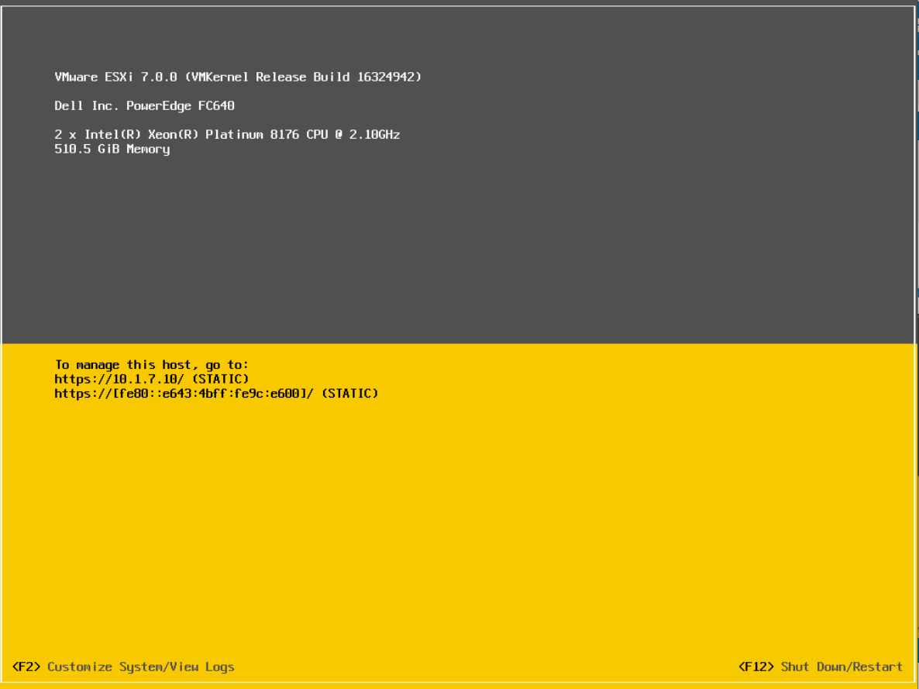

15. Open up a Google Chrome Browser from the laptop and navigate to the ESXi IP at <http://10.1.x.10> Log in using the user of 'root' and password '**Br111ckSquad**!!!'.

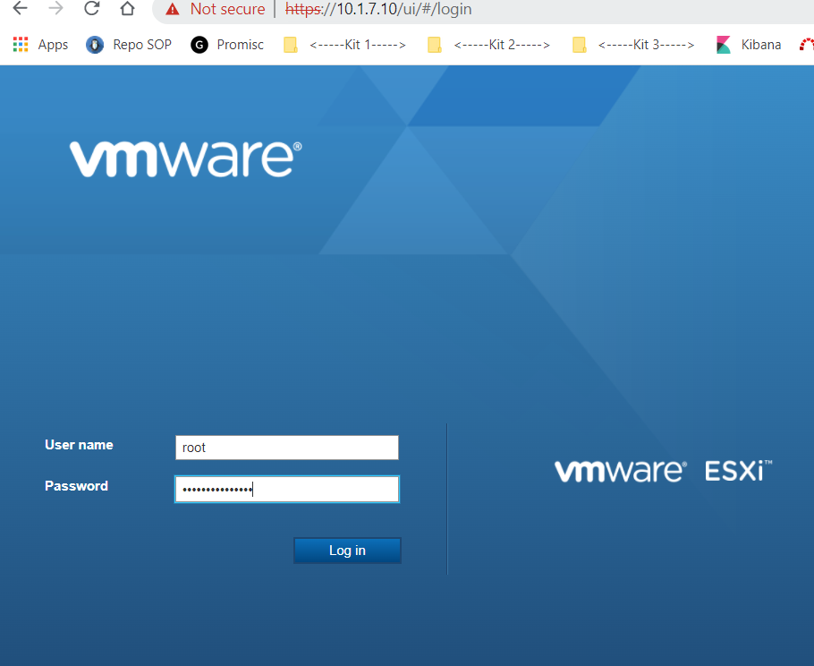

**\*\*\*\*\*\*\*\*THE FOLLOWING STEPS ARE ONLY FOR KIT 1 AND KIT 3\*\*\*\*\*\*\*\***

**IF YOU ARE MANAGING KIT2, SKIP BELOW TO STEP 29**

16. On the left-hand side of the webpage will be a short list. Click on the item that says "Virtual Machines". When they load, select the checkbox next to the VM’s titled ‘pfSense -.1’ and ‘Splunk - .50’ select the "Power On" option.

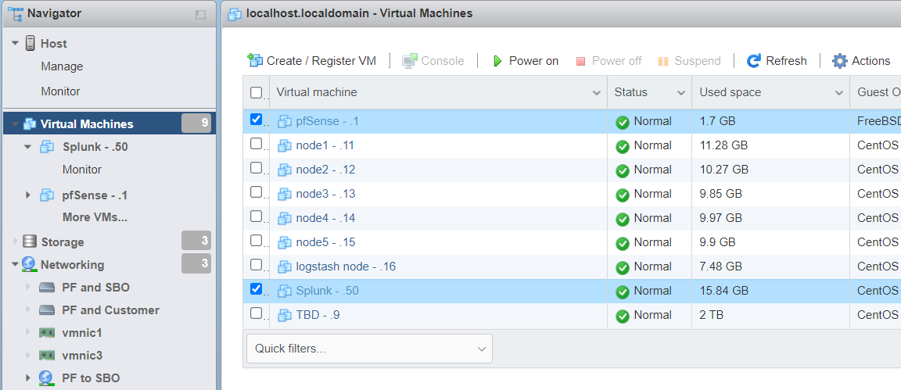

17. Click on the VM titled "Splunk -.50", then click the thumbnail to enter the virtual machine.

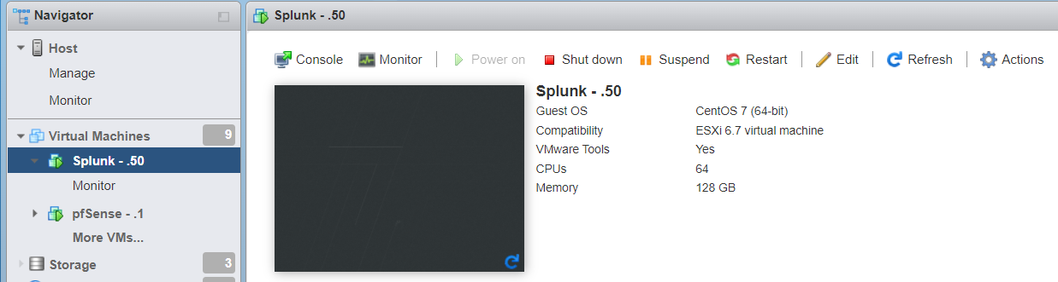

18. Log in under the default user(should be named "gucci") with the password '**Br111ckSquad!!!**'.

19. Right-click on the desktop of the VM and select "open terminal". Type in the following commands: (note: if prompted for a password, use the ‘**Br111ckSquad!!!**’ password.)

cd /opt/splunk/bin

sudo ./splunk start

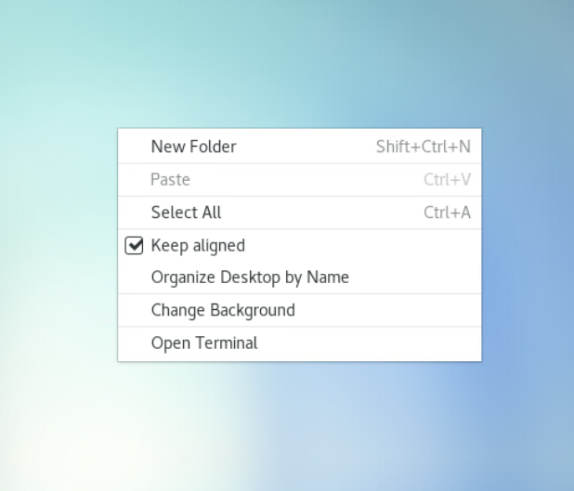



20. You should see the below result of the command you just ran if things ran right. If you do not see this result, contact infrastructure personnel for help. (Note: the kit number may change



21. Navigate the the Blade 2 iDRAC IP at <http://10.1.x.4> Log in with the user of 'root' and the password '**Br111ckSquad!!!**'.



22. Scroll to the bottom of the page once logged in. On the right side of the web page will be a thumbnail underneath a title that says "Virtual Console". Click on the thumbnail, even if it says "No Signal".



23. The boot process for Blade 2 should be complete by now. If not, wait for it to complete. When it is complete, there will be a login prompt for the user "gucci", or a blue screen with the time on it. Log in with the password '**Br111ckSquad!!!**'. If the blue screen is what you see, click and drag upwards to get to the login prompt. If the screen is green and says "No Input", try to wake the server be clicking on the screen. If it doesn't work, contact infrastructure personnel for help.

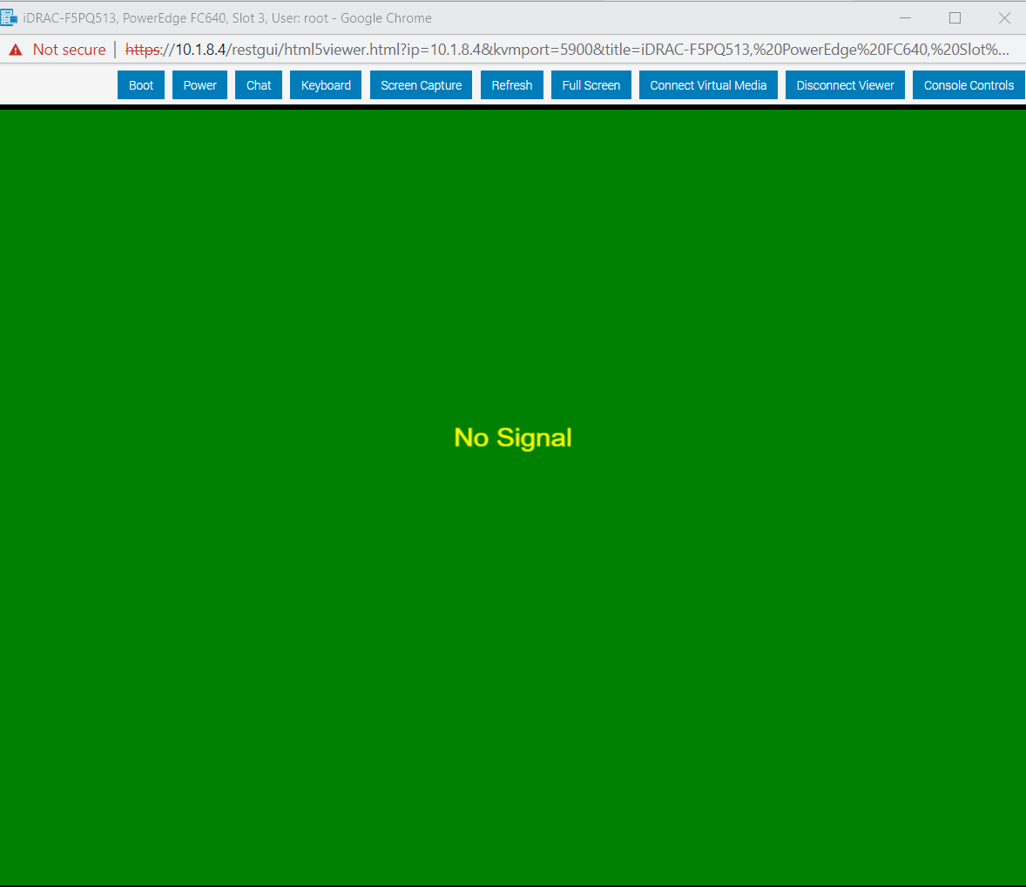

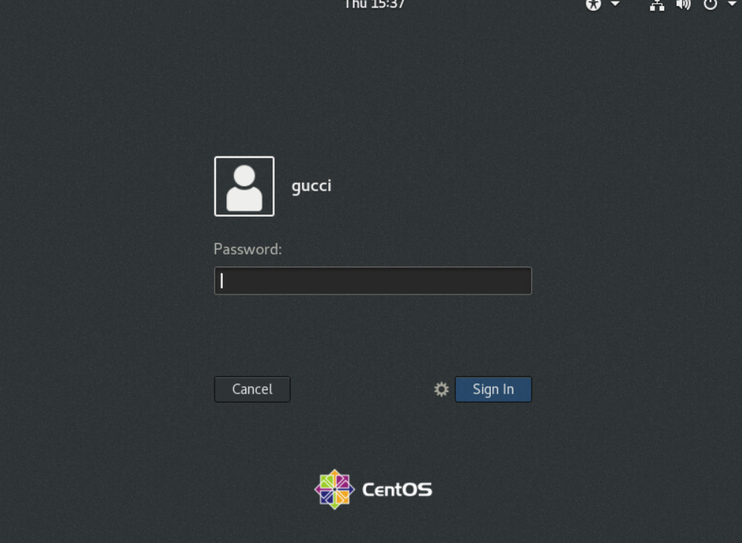

24. Right click on the Blade 2 desktop after logging in, and select "open terminal"



25. On the terminal session, type in “systemctl status suricata” to verify that it is active and running. If it is not running, type in “sudo systemctl start suricata” and when prompted, use the ‘**Br111ckSquad!!!**’ password. Verify it is up and running with “systemctl status suricata”. If it is not active and running after trying to start it, contact infrastructure personnel for help.

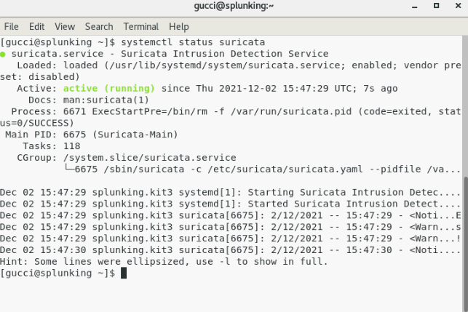

26. 25. On the terminal session, run the following commands: (note: if prompted for a password, use the ‘**Br111ckSquad!!!**’ password.)

sudo zeekctl start

sudo zeekctl status

cd /opt/splunkforwarder/bin

sudo ./splunk start

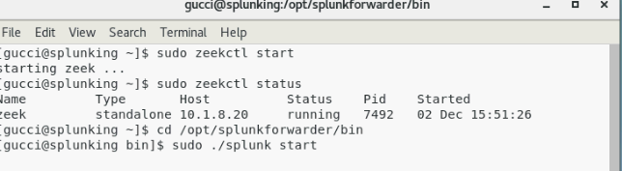

27. After starting the splunk service, you should see the following result in the terminal. If you do not see the result, contact infrastructure personnel for help.



28. To verify Splunk is working, type into a Google Chrome Browser "**http://10.1.x.50:8000**". Ensure you type in the port "8000" to reach the search head. Even if you don't see data, if you have a web page, you have completed the Power on and Startup. Log in with the user “gucci” and the ‘**Br111ckSquad!!!**’ password. SEE BELOW:

**\*\*\*\*\*ONLY FOR KIT 2, THE NAS AND TICKETING KIT\*\*\*\*\***

29. On the left-hand side of the webpage will be a shot list. Click on the item that says "Virtual Machines". When they load, select the checkbox next to the VM’s titled ‘pfSense -.1’, ‘ROCKETCHAT WEKAN - .200’, ‘MISP - .205’ and ‘REDMINE - .210’, then select the "Power On" option.

30. Test that each service is working by navigating to the following addresses in your browser: (note: if you are unable to reach any of the below addresses, contact infrastructure personnel for help)

<http://10.1.7.200:3000>

<http://10.1.7.200:3001>

<http://10.1.7.205>

<http://10.1.7.210>

31. Next, navigate to <http://10.1.7.20>. It is another ESXi instance, and you will log in with user ‘root’ and the ‘**Br111ckSquad!!!**’ password. There is only one virtual machine here, labelled ‘NAS - .21’. Select the checkbox next to that VM, then select the “Power On” option.

32. Verify connectivity to the NAS by navigating to <http://10.1.7.21> . If you are met with a log in prompt, you have successfully completed power on and startup.

**POWER OFF STEPS:**

1. Navigate and log into ESXi the same as steps 15 and 16(29 and 31 for kit 2). Select all of the VM's that were selected previously, but this time, select "Power Off Virtual Machines". When the dialogue box pops up, click the "reload" button.

2. Wait for that to complete, then log into the CMC by navigating back the CMC IP at <http://10.1.x.2> and select the server for Blade 1 as if you were to power it on.

3. Go to power, then select control, then select the radio button next to "Power Off", then click apply. Select "yes" when asked if you want to execute a server control action.

4. Repeat step 3. for Blade 2.

5. Select "Chassis Overview" at the top of the page, then select "Power" and select "Control". Then select the radio button next to "Power Off", then click apply. Select "yes" when asked if you want to execute a server control action.

6. When fans stop spinning loudly, the kit is powered off. Unplug all cabling and store the Chassis and Blades in their corresponding pelican cases.